
The meeting of Satterthwaite Parish Council to be held in the Parish Room, Satterthwaite on Monday 19th January 2026 at 7.30 pm for the purpose of transacting the business outlined in the agenda below.
Agenda
Item |  | Additional  information
Opening Administration
1 | Welcome and Introductions  Apologies  None received
2 | Declarations of interest  - To receive declarations by elected and co-opted members of disclosable pecuniary interests in respect of items on this agenda
3 | Requests for Dispensations  - The clerk to report any requests received since the previous meeting for dispensations to speak and/or vote on any matter where a member has a disclosable pecuniary interest.
4 | Minutes  - To authorise the Chair to review and sign last meetings minutes on 1st of December 2025 | Minutes attached from 1st Dec 2025
Matters for consideration
5 | Public participation  - To receive comments and representations from members of the public in relation to any item on the agenda
6 | Updates on ongoing issues and actions from last meeting  Review of action log  - LDNPA and Dale Park caravan update – new shed reported  - Playground quotes  - Zurich insurance  - Observatory visit plans for community  - Village Parking – photos to be collected  - Moor lane and motorcyclists  - Standing Orders/Financial regs  - Meeting with HIAMS - tbc | Action log in agenda pack
7 | Items for meeting not covered above  - Governance review draft report  - Gritting
8 | Additional or urgent points to raise regarding Parish or Councillor matters  - Fibrus and road closures
9 | Items for the Lengthsman
Planning
10 | Planning Consultations sought from Parish Council  None
Finance
11 | Accounts since last meeting  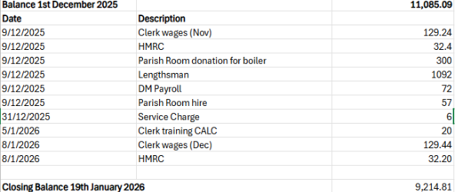
12 | Precept
Key correspondence, consultations and reports not covered above
13 | Cumbria CVS – flood sacks
14 | W&F anti-social behaviour plans
15 | W&F long distance walking trail
16 | Removal of Sport England as statutory consultee in planning
17 | W&F Annual Budget Consultation
18 | Community Governance review – Draft report
19 | Internal audit service EOI
Council calendar
20 | Games night to be arranged  Observatory visit to be arranged
Closing administration
21 | Agenda items for next meeting
22 | Next meeting date to be agreed  - 3rd March 2026

